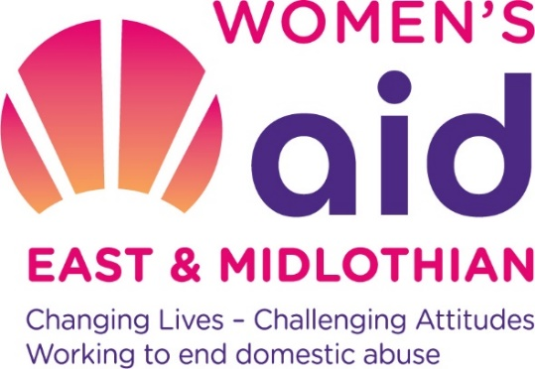

Info for Applicants
WANTED - Women who want to make a difference
Women’s Aid East and Midlothian (WAEML) aims to empower women until all women, children and young people are free and safe from domestic abuse. We are currently seeking a Communications and Social Media Volunteer to join our team as we enter an exciting new phase of growth and development.
If you share our core values, have a passion for women’s and children’s rights and would like to help us make a real difference to women and children’s lives this could be the role for you. If you want to discuss the role in more detail you can chat to our CEO, Julie Watson – she can be contacted at: julie@womensaideml.org.
Application

Please submit a copy of your CV along with the Volunteer application form (attached) by email. Please write Communications and Social Media Volunteer in the subject line. Applications should be received by noon on Wednesday 7th July 2021 to Nancy Ross: nancy@womensaideml.org.

Shortlisted applicants will be invited to a virtual interview within one month of the closing date.

More about the role

We are looking for a volunteer to look after our social media platforms and to help us develop an on line presence for a new exciting project to open a Women’s Empowerment Centre in Midlothian.
This will include updating our social media, especially Facebook, Twitter and Instagram as well as exploring new ways to engage our followers and share our message. We need someone who can create new and engaging posts and materials.
You will also be asked to lead on creating a communications calendar and strategy and assist us with developing a website specifically for this project.

What WAEML will provide to Volunteers:
- An induction meeting with the CEO of WAEML, who will also check in with you on a regular basis to ensure you are comfortable with your role.
- You will be allocated a line manager who will liaise more regularly to allocate tasks and ensure you have everything you need.
- You will receive a written pack containing background information about WAEML.
- You will be invited to meet key members of staff during your induction period and the CEO will also be available to answer any ongoing questions you have relating to your specific role.
- You will be invited to attend WAEML activities and events in order to help familiarise yourself with the organisation.
- You will be part of a supportive team including members of the Board of Directors.

Volunteering benefits:
- To know you are playing an essential role in WAEML, enabling the organisation to keep our supporters updated on progress with this new project but also to seek support and investment to realise our ambition.
- To build up new and existing skills and knowledge relating to the development of a small, dynamic voluntary organisation.
- To learn more about a range of issues including social exclusion, volunteering, equality to name but a few!
- To be part of the WAEML community and be invited to a range of fun and inspiring events.

Application process:
- Complete the Volunteer application form and send us a copy of your CV, please explain your interest in joining our team and the skills you have in relation to the role specification.
- Applications and CVs will be scored by a recruitment panel, we will interview up to six candidates who meet the requirements of the role.
- If you are short listed for the post, we will invite you to attend a recruitment interview with the CEO, a Trustee Director and a service user who will discuss with you individually your ability to carry out the role. You will also be given the opportunity to ask questions about the organisation or role of Volunteer.

